**TOMATO - FOOD DELIVERY APP**

A

HCI Course Project Report

**Bachelor of Technology**

in

**Computer Science & Engineering**

**By**

Name: A.Shashidhar HT No : 2303A51798

Name:J.Mukhesh HT No : 2303A51813

Name:G.Bhagath HT No : 2303A51807

(**Tomato – Food Delivery App**)

Under the guidance of

**Faiza iram**

**Assistant Professor**

**Submitted to**

**School of Computer Science and Artificial Intelligence**

**DEPARTMENT OFCOMPUTERSCIENCE& ENGINEERING**

**CERTIFICATE**

This is to certify that the **Human Computer Interface – Course Project** Report entitled **“Tomato – Food Delivery App”** is a record of bonafide work carried out by the student(s) A.Shashidhar, J.Mukesh, G.Bhagath bearing Hall ticket No(s): 2303A51798, 2303A51813, 2303A51807 during the academic year 2024-25 in partial fulfillment of the award of the degree of ***Bachelor of Technology*** in **Computer Science & Engineering** by the SR University, Warangal.

**Supervisor Head of the Department**

(Mrs. Faiza Iram ) (Dr. M. Sheshikala)

Assistant Professor Professor

ACKNOWLEDGMENT

We owe an enormous debt of gratitude to our project guide Mr. Bediga Sharan Assistant Professor as well as Head of the CSE Department Dr. M. Sheshikala, Associate Professor for guiding us from the beginning through the end of the Project with their intellectual advices and insightful suggestions. We truly value their consistent feedback on our progress, which was always constructive and encoraging and ultimately drove us to the right direction. We wish to take this opportunity to express our sincere gratitude and deep sense of respect to our beloved Vice Chancellor, Prof. Deepak Garg, for his continuous support and guidance to complete this project in the institute. Finally, we express our thanks to all the teaching and non-teaching staff of the department for their suggestions and timely support.

|  |  |
| --- | --- |
| Concepts | Page.no |
| TITLE | 01 |
| CERTIFICATE | 02 |
| ACKNOWLEDGMENT | 03 |
| OBJECTIVE | 06 |
| EXISTING SYSTEM | 07 |
| PROPOSED SYSTEM | 08 |

|  |  |
| --- | --- |
| SOFTWARE | 09 |
| IMPLEMENTATION  CODE | 10 |
| DESIGN | 47 |
| CONCLUSION | 50 |

ABSTRACT

*Tomato* is an innovative food delivery platform designed to connect customers with their favorite local restaurants and eateries. The app offers a seamless, user-friendly experience, allowing users to browse menus, customize orders, and track deliveries in real-time. With a focus on convenience and efficiency, *Tomato* incorporates features like advanced search filters, personalized recommendations, and secure payment options to cater to diverse culinary preferences.

For restaurants, *Tomato* provides a robust platform to expand their reach and streamline operations through easy order management and data-driven insights. The app emphasizes sustainability with eco-friendly packaging options and supports local businesses by highlighting them through targeted promotions.

Whether satisfying late-night cravings or planning group meals, *Tomato* ensures quick, reliable service, delivering delicious food to your doorstep with just a few taps.

OBJECTIVE

The *Tomato* food delivery app is designed to redefine how customers connect with their favorite restaurants, offering a seamless and enjoyable experience for ordering food. Its primary objective is to create a platform that serves as a reliable bridge between food lovers and eateries, focusing on convenience, efficiency, and innovation.

One of the key goals of *Tomato* is to enhance user convenience. The app achieves this by providing an intuitive interface that allows customers to browse menus, customize orders, and track their deliveries in real time. By incorporating personalized recommendations based on user preferences, the app ensures that customers can discover meals that suit their tastes effortlessly. The streamlined ordering process and secure payment options make the entire experience quick and hassle-free.

Another critical objective is empowering restaurants. The *Tomato* platform enables local restaurants to expand their reach to a wider audience, thereby increasing their revenue potential. Restaurants can manage orders efficiently and access valuable insights through analytics provided by the app. This helps them optimize their services and tailor their offerings to meet customer demands effectively.

*Sustainability* is a core value of the *Tomato* app. In an effort to promote eco-friendly practices, the app encourages the use of sustainable packaging options and explores green delivery methods. By addressing the environmental impact of food delivery, *Tomato* strives to contribute to a healthier planet while meeting customer expectations.

The app also focuses on supporting local economies by promoting small and neighborhood eateries. These establishments are often highlighted within the app, helping them gain visibility and attract more customers. This initiative not only benefits the restaurants but also strengthens the bond between communities and their local businesses.

Quality and reliability remain top priorities for *Tomato*. The app ensures timely deliveries and maintains high standards for food quality, fostering trust and loyalty among its users. By providing dependable service, *Tomato* aims to become a trusted partner for customers seeking delicious meals and for restaurants looking to grow their businesses.

EXISTING SYSTEM:

Food delivery platforms such as Swiggy, Zomato, Uber Eats, and DoorDash have revolutionized how people order food, making the process seamless and highly convenient. These systems offer intuitive user interfaces that allow customers to browse menus, filter options based on cuisine or price, and place orders effortlessly. Real-time tracking of deliveries, secure payment options, and notifications further enhance the overall experience.

For restaurants, these platforms provide dashboards to manage orders efficiently. They can update menus, monitor customer preferences, and analyze performance metrics to improve their services. By integrating with these systems, restaurants can streamline operations and reach a broader audience.

Delivery networks form the backbone of these systems, ensuring timely and efficient service. Algorithms are used to optimize delivery routes, minimizing delays and maximizing efficiency. Delivery partners use dedicated apps to manage pickups and navigate effectively.

Customer support mechanisms ensure issues like delays or incorrect orders are promptly addressed. Many platforms offer 24/7 support through chatbots, live agents, and feedback channels, creating a reliable and responsive experience. Additionally, promotional offers and subscription models such as Zomato Pro or DoorDash DashPass provide perks like free deliveries and exclusive discounts, encouraging customer loyalty.

In conclusion, existing food delivery platforms have set a high standard in terms of convenience, efficiency, and user experience. However, addressing challenges related to costs, delays, and sustainability offers opportunities for further improvement, paving the way for more innovative and inclusive food delivery solutions.

PROPOSED SYSTEM:

The *Tomato* food delivery app is designed to address the challenges of existing platforms while offering an innovative and customer-centric experience. By focusing on enhancing user convenience, supporting local businesses, optimizing delivery processes, and promoting sustainability, *Tomato* aims to create a food delivery service that not only meets current demands but also anticipates future needs.

**Enhanced User Convenience:**  
The user interface of the *Tomato* app will be clean and intuitive, enabling customers to browse menus, apply advanced filters (such as dietary preferences and allergens), and place orders effortlessly. Real-time tracking will allow users to monitor the progress of their orders with accurate estimated delivery times. With the goal of further improving convenience, the app will introduce personalized recommendations based on customer history, preferences, and current food trends, ensuring that users can discover meals that suit their tastes easily.

Efficient Delivery Network:

To minimize delays and improve service quality, the Tomato app will employ AI and machine learning to optimize delivery routes. This technology will help reduce delivery times by identifying the fastest, most efficient paths for drivers. Furthermore, Tomato will introduce a "batch delivery" model, which consolidates multiple orders in close proximity to reduce both delivery costs and time, benefiting both customers and restaurants by improving operational efficiency.

**Improved Customer Support:**  
The *Tomato* app will provide 24/7 customer support through AI-powered chatbots and live agents. To enhance the user experience, the app will introduce proactive resolution systems for issues such as delayed or incorrect orders. Customers who face problems will be quickly compensated with refunds or discounts, ensuring that the platform maintains a high level of customer satisfaction.

**Subscription Model and Loyalty Program:**  
To retain customers and encourage frequent use, *Tomato* will offer a subscription model, which grants users perks like free deliveries and exclusive discounts. Additionally, a loyalty program will reward frequent customers with points that can be redeemed for discounts, free items, or special offers. This will not only encourage repeat usage but also foster a sense of community among *Tomato* users.

SOFTWARE REQUIREMENTS:

TECHNICAL REQUIREMENTS:

* HTML
* CSS
* JAVASCRIPT

HARDWARE REQUIREMENTS:

**Server:**

A reliable and scalable server is essential to host the **Tomato – Food Delivery App** system's web application and database. The server should have a multi-core processor, at least 16GB of RAM, and a minimum of 500GB SSD storage to handle multiple concurrent users, manage data processing, and support the application's performance.

**Database Server:**

A dedicated database server to securely store and manage extensive data, including university information, student profiles, application details, and consultation records. It should feature a high-performance CPU, 16GB or more RAM, and at least 1TB of storage to accommodate growing data requirements.

**Network Infrastructure:**

High-speed and reliable network infrastructure is crucial for seamless communication between the server and users. This includes robust networking equipment such as routers and switches, alongside a high-bandwidth internet connection to ensure uninterrupted access to the platform, even during peak usage times.

IMPLEMENTATION OF CODE:

In this project we make different parts of code. Because of each code file show some attribute.

*index.html

*services.html

*destinations.html

*about.html

*contact.html

*style.css

*script.js

## <html>

## <title>Tomato - Food Delivery</title>

## <link rel="stylesheet" href="hci.css">

## <link rel="stylesheet" href="https://cdnjs.cloudflare.com/ajax/libs/font-awesome/6.6.0/css/all.min.css">

## <script src="hci.js" defer></script>

## </head>

## <body>

## <!-- Header -->

## <header>

## <div class="logo">

## <h1>Tomato</h1>

## </div>

## <nav>

## <ul>

## <li><a href="#home">Home</a></li>

## <li><a href="#Menu">Menu</a></li>

## <li><a href="#Contact Us">Contact Us</a></li>

## <li><a href="#Log in">Log In</a></li>

## </ul>

## </nav>

## <!-- Icons Section -->

## <div class="actions">

## <!--Search Icon -->

## <div id="search-container" style="display: none;">

## <input type="text" id="search-input" placeholder="Search...">

## <button id="search-btn">Search</button>

## </div>

## <a href="#" id="search-toggle"><i class="fa-solid fa-magnifying-glass"></i></a>

## <!-- Cart Icon -->

## <a href="#" id="cart-icon"><i class="fa-solid fa-cart-shopping"></i></a>

## <div id="cart-modal" class="hidden">

## <h2>Cart Items</h2>

## <ul id="cart-items"></ul>

## <p id="empty-cart-message" class="hidden">Your cart is empty.</p>

## <button id="close-cart">Close</button>

## </div>

## </header>

## <!-- Home Section -->

## <section id="home" class="menu-section">

## <h2>Our Food Catagories</h2>

## <p>Choose from a diverse menu featuring a delectable array of dishes.</p>

## <div class="menu-items">

## <div class="menu-item">

## <img src="images/t3.jpeg" alt="Salad">

## <p>Salad</p>

## </div>

## <div class="menu-item">

## <img src="images/t4.webp" alt="Rolls">

## <p>Rolls</p>

## </div>

## <div class="menu-item">

## <img src="images/t5.jpeg" alt="Desserts">

## <p>Desserts</p>

## </div>

## <div class="menu-item">

## <img src="images/t6.jpeg" alt="Sandwich">

## <p>Sandwich</p>

## </div>

## <div class="menu-item">

## <img src="images/t7.jpeg" alt="Cake">

## <p>Cake</p>

## </div>

## <div class="menu-item">

## <img src="images/t8.jpeg" alt="Pure Veg">

## <p>Pure Veg</p>

## </div>

## <div class="menu-item">

## <img src="images/t9.jpeg" alt="Pasta">

## <p>Pasta</p>

## </div>

## <div class="menu-item">

## <img src="images/t10.jpeg" alt="Noodles">

## <p>Noodles</p>

## </div>

## <div class="menu-item">

## <img src="images/t11.jpeg" alt="Chicken">

## <p>Chicken</p>

## </div>

## <div class="menu-item">

## <img src="images/t41.jpeg" alt="Pizza">

## <p>Pizza</p>

## </div>

## <div class="menu-item">

## <img src="images/t42.jpeg" alt="Burger">

## <p>Burger</p>

## </div>

## <div class="menu-item">

## <img src="images/t40.jpeg" alt="Sushi">

## <p>Sushi</p>

## </div>

## <div class="menu-item">

## <img src="images/t43.jpeg" alt="Steak">

## <p>Steak</p>

## </div>

## <div class="menu-item">

## <img src="images/t44.jpeg" alt="Seafood">

## <p>Seafood</p>

## </div>

## <div class="menu-item">

## <img src="images/t45.jpeg" alt="Tacos">

## <p>Tacos</p>

## </div>

## <div class="menu-item">

## <img src="images/t46.jpeg" alt="Smoothies">

## <p>Smoothies</p>

## </div>

## </div>

## </section>

## <!-- Catagorie Section -->

## <title>Food Menu</title>

## <link rel="stylesheet" href="style.css">

## <div class="menu-container">

## <table>

## <thead>

## <tr>

## <th>Image</th>

## <th>Item</th>

## <th>Category</th>

## <th>Price</th>

## </tr>

## </thead>

## <tbody>

## <tr>

## <td><img src="images/t32.jpeg" alt="Garlic Mushroom"></td>

## <td>Garlic Mushroom</td>

## <td class="menu-category">Pure Veg</td>

## <td>$5</td>

## </tr>

## <tr>

## <td><img src="images/t33.jpeg" alt="Fried Cauliflower"></td>

## <td>Fried Cauliflower</td>

## <td class="menu-category">Pure Veg</td>

## <td>$12</td>

## </tr>

## <tr>

## <td><img src="images/t34.jpeg" alt="Veg Platter"></td>

## <td>Veg Platter</td>

## <td class="menu-category">Pure Veg</td>

## <td>$8</td>

## </tr>

## <tr>

## <td><img src="images/t35.jpeg" alt="Rice Zucchini"></td>

## <td>Rice Zucchini</td>

## <td class="menu-category">Pure Veg</td>

## <td>$9</td>

## </tr>

## <tr>

## <td><img src="images/t36.jpeg" alt="Cheese Pasta"></td>

## <td>Cheese Pasta</td>

## <td class="menu-category">Pasta</td>

## <td>$10</td>

## </tr>

## <tr>

## <td><img src="images/t37.jpeg" alt="Tomato Pasta"></td>

## <td>Tomato Pasta</td>

## <td class="menu-category">Pasta</td>

## <td>$8</td>

## </tr>

## </tbody>

## </table>

## </div>

## 

## 

## <!-- Menu Section -->

## <section id = "Menu" class="dishes-section">

## <h2>Explore our Menu</h2>

## <div class="dish-grid">

## <div class="dish-item">

## <img src="images/t38.jpeg" alt="Dish 1">

## <div class="dish-info">

## <h3>Greek Salad</h3>

## <p>A refreshing blend of greens and zesty flavors.</p>

## <div class="price-rating">

## <span class="price">$12</span>

## <span class="stars">⭐⭐⭐⭐☆</span>

## </div>

## <div class="cart-controls">

## <div class="quantity-controls">

## <button class="minus">-</button>

## <input type="number" class="quantity" value="1" min="1">

## <button class="plus">+</button>

## </div>

## <button class="add-to-cart">Add to Cart</button>

## </div>

## </div>

## </div>

## <div class="dish-item">

## <img src="images/t13.jpeg" alt="Dish 2">

## <div class="dish-info">

## <h3>Pasta Delight</h3>

## <p>Rich and creamy pasta with a burst of Italian spices.</p>

## <div class="price-rating">

## <span class="price">$15</span>

## <span class="stars">⭐⭐⭐⭐⭐</span>

## </div>

## <div class="cart-controls">

## <div class="quantity-controls">

## <button class="minus">-</button>

## <input type="number" class="quantity" value="1" min="1">

## <button class="plus">+</button>

## </div>

## <button class="add-to-cart">Add to Cart</button>

## </div>

## </div>

## </div>

DESIGN :

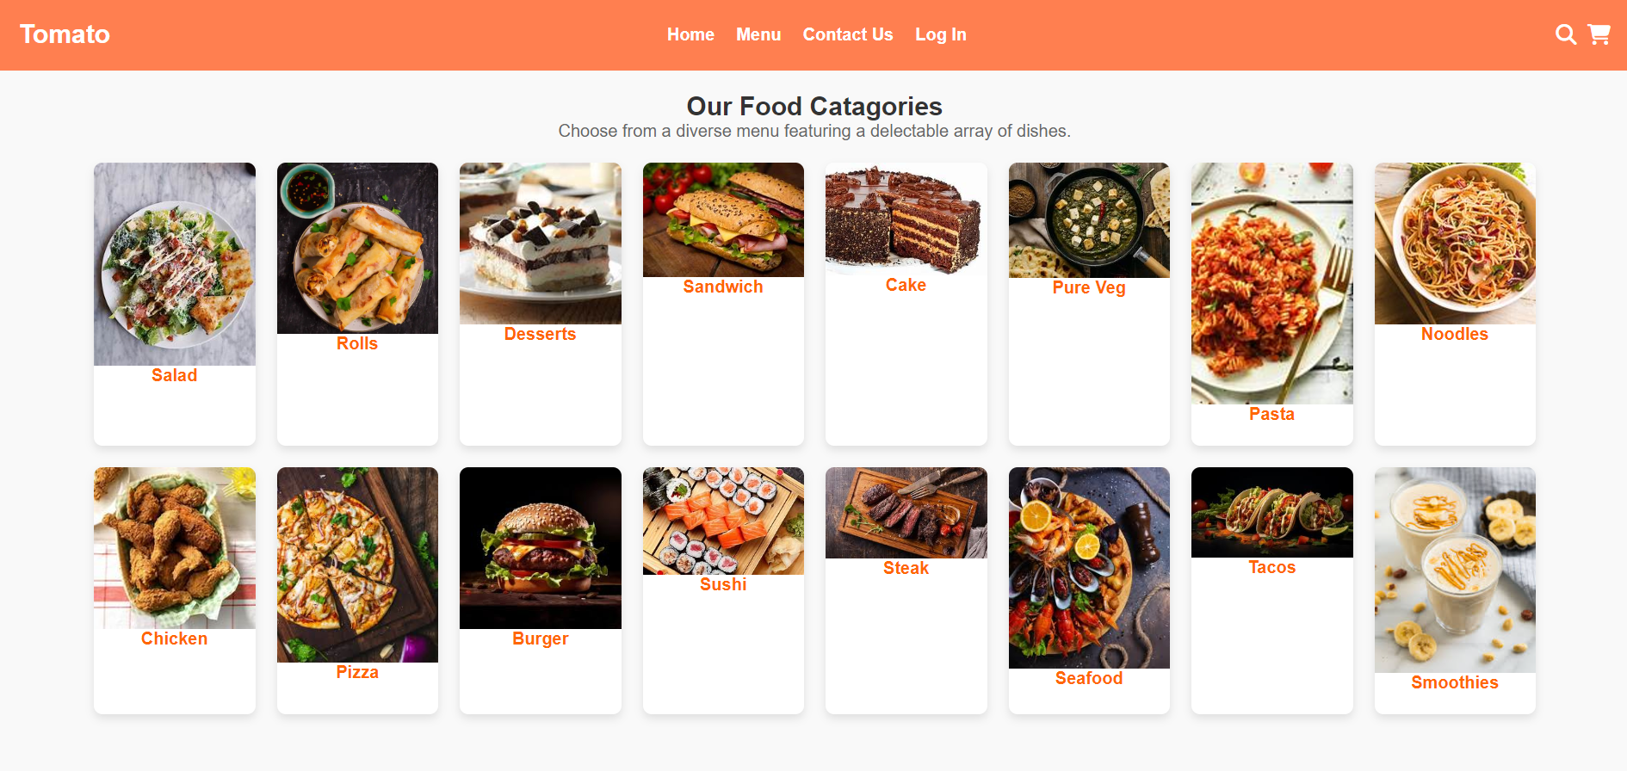

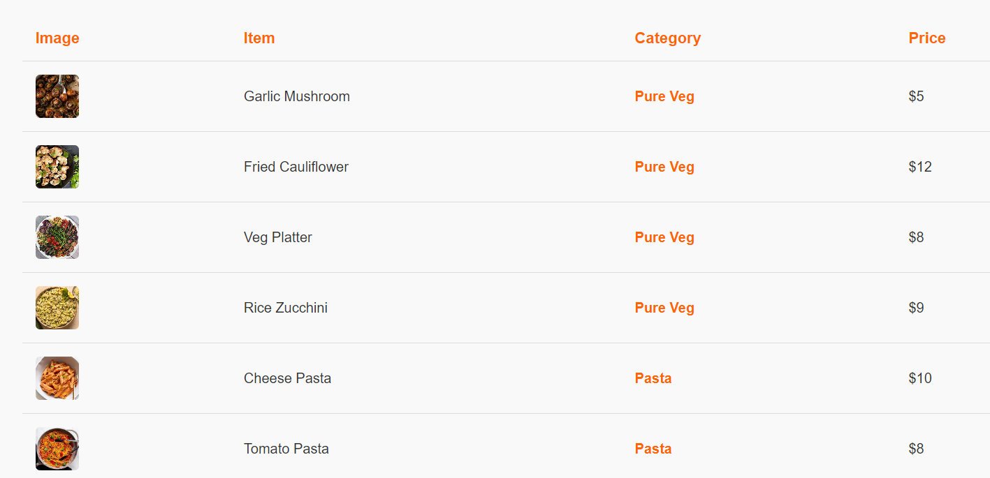

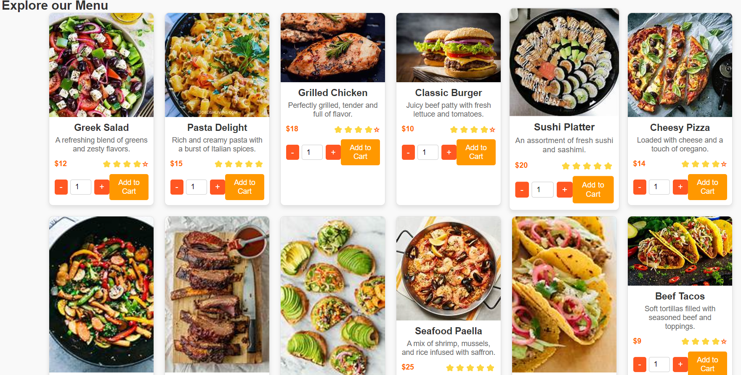

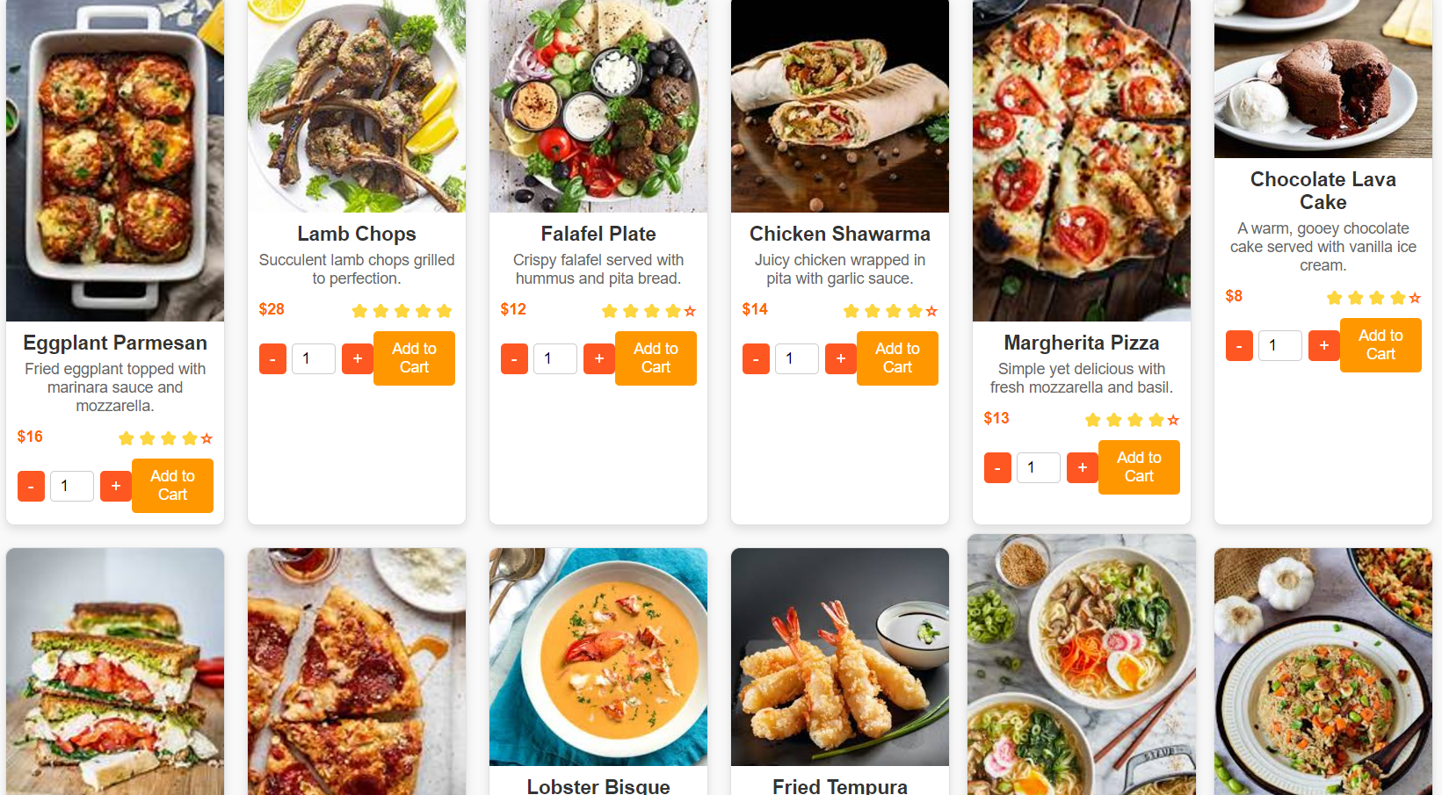

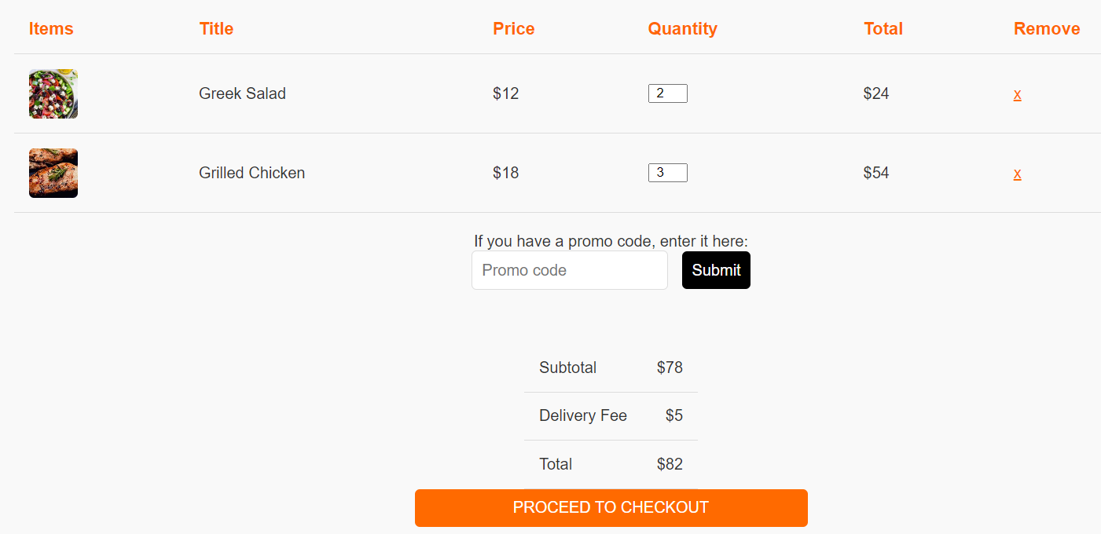 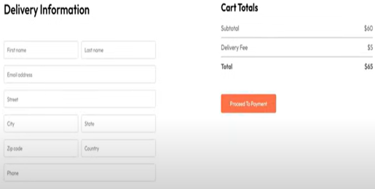

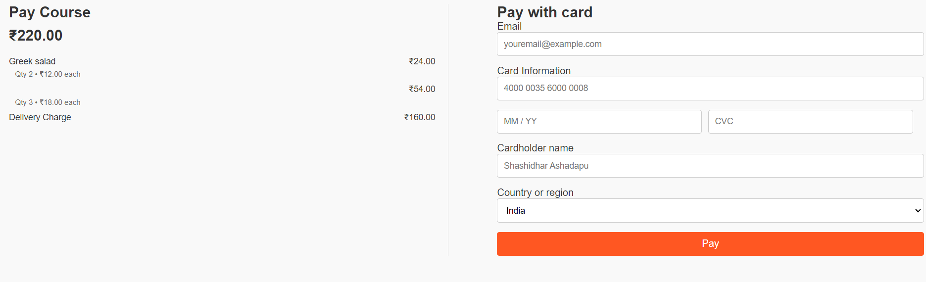

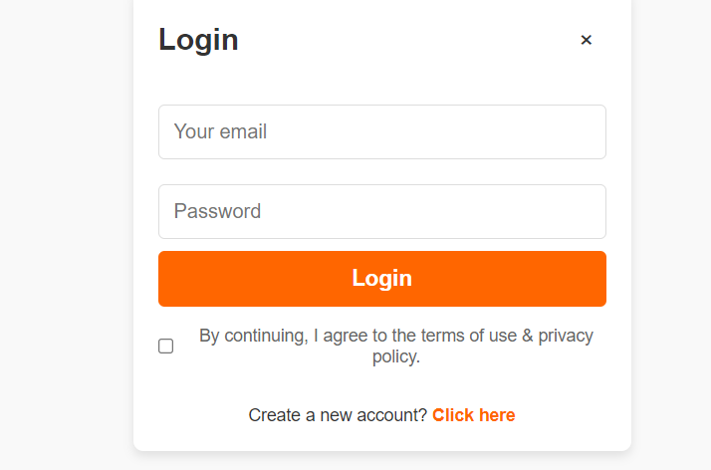

CONCLUSION:

The proposed *Tomato* food delivery app presents a comprehensive solution that addresses the gaps in existing platforms by focusing on user convenience, cost efficiency, support for local businesses, and sustainability. Through advanced technologies like AI for route optimization, personalized recommendations, and a dynamic pricing structure, *Tomato* aims to provide a seamless and cost-effective experience for both customers and restaurants.

By prioritizing local businesses, offering eco-friendly options, and incorporating proactive customer support, *Tomato* seeks to build a community-driven platform that benefits all stakeholders. The addition of a subscription model, loyalty programs, and social features further enhances the overall user experience, making *Tomato* a competitive and forward-thinking player in the food delivery market.

Ultimately, *Tomato* aspires to set a new standard for food delivery services, one that is efficient, affordable, and environmentally conscious, creating value for customers, restaurants, and the broader community alike.